**Watergate Webquest**

**Name:**

**Instructions:** *Conduct online research using resources that chronicle the Watergate scandal and respond to these prompts in complete sentences!*

Use the Following Resources To Help With Your Research:

• <http://www.washingtonpost.com/wp-srv/national/longterm/watergate/front.htm>

• <http://vcepolitics.com/watergate/>

• <http://www9.cnn.com/ALLPOLITICS/1997/gen/resources/watergate/index.html>

• <http://www.washingtonpost.com/wp-srv/national/longterm/watergate/deept.htm>

• <http://www.washingtonpost.com/wp-srv/national/longterm/watergate/articles/061872-1.htm>

• <http://www.whitehouse.gov/history/presidents/rn37.html>

• <http://www.nixonlibraryfoundation.org/>

* <http://www.ford.utexas.edu/museum/exhibits/watergate_files/content.php?section=1&page=b&person=2>

1. Identify where the Watergate hotel is located on the map. (*Please write about the location*) **\*For 2 extra credit points, copy/paste a the hotel’s location.\***

The Watergate Hotel is located in Washington, D.C. on the edge of Georgetown. The Kennedy Center for performing arts is next to it. The address is 2650 Virginia Avenue NW.

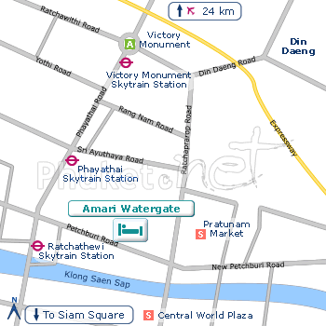

1. Summarize the events that happened there on June 17, 1972.
2. Identify the main players in the Watergate scandal and the role each played.

Frank Sturgis:

Bernard Barker:

Eugenio Martinez:

Virgilio Gonzalez:

James McCord:

1. Explain why the President had recording devices installed in his office.
2. Identify some of the individuals President Nixon taped.
3. Determine if those being taped were aware of it.
4. Identify the members of the “Plumbers.”
5. Explain why this group of men was called “The Plumbers.”
6. List what the “Plumbers” did, for whom they worked, and two deeds these men stood accused of perpetrating.
7. Does a President have the constitutional authority to break the law?
8. Is there ever a time in which the President is justified in breaking the law or in authorizing others to break the law? Provide examples and explain your thinking.