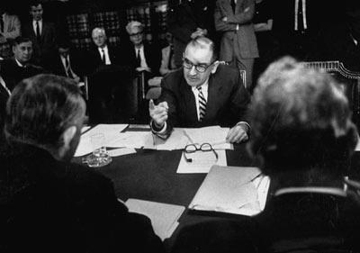
How McCarthyism Worked
Mass hysteria has reared its ugly head for as long as humans have existed. Adolf Hitler worked enough people into a frenzy to justify the murder of millions of Jews. Jesus Christ, known by all as peaceful, if controversial, was brutally nailed to a cross because a few high-ranking officials felt threatened by him. Although one would hope that people would learn a lesson or two from the mistakes of the past, it seems that history, as the old cliché goes, is forever doomed to repeat itself.
Hank Walker/Time Life Pictures/Getty Images
Joseph R. McCarthy vigorously makes a point at a Senate Judiciary Committee hearing.
Enter Senator Joseph McCarthy. While he may not have caused genocide or murdered a prophet, he was able to whip up hysteria in America in the early 1950s. McCarthy's issue of choice? Communism. The American Heritage Dictionary defines McCarthyism as "the political practice of publicizing accusations of disloyalty or subversion with insufficient regard to evidence."
Communism, in simple terms, is an economic system designed to equally benefit everyone in the society. The idea is that everyone contributes to the society and gets an equal share of property and goods. Communist systems are generally controlled by dictators and totalitarian governments -- think China, Cuba and North Korea.
By the '50s, communism wasn't exactly a new worry for the United States. In the aftermath of World War I, the country had experienced the First Red Scare ("red" is slang for communism). Russia had a new communist government as a result of the Bolshevik Revolution in 1917, and dictator Vladimir Ilyich Ulyanov (Lenin) had brutally slaughtered about 9 million of his people for resisting his ideals [source: The History Guide]. All of this upheaval upset Americans, so lawmakers decided to prevent the spread of communism to the United States by enforcing the Sedition Act and the Espionage Act. The First Red Scare was characterized by the ferocity with which the U.S. government identified and attacked suspected communists.
By the time McCarthy won a Senate seat in 1946, World War II was over and the Cold War was beginning. Communist governments had gained hold in Eastern Europe and China, and Americans were increasingly concerned about it -- and about rumors of high-ranking U.S. government officials who were secret communists. McCarthy took advantage of the mounting fear, but because it isn't actually illegal to be a communist, he started charging people with the act of subversion -- the "systematic attempt to overthrow or undermine a government or political system by persons working from within" [source: Merriam-Webster's Dictionary of Law]. Then he got to work prosecuting them for selling or giving American security secrets to communist governments.
In this article, you'll learn about the basics of communism, McCarthy's interview tactics, and recent evidence about the communist presence in the United States at the time of McCarthyism. You'll also learn about the impact of McCarthy's accusations on the lives of the accused, the country as a whole and his own family name.

The Rise of Joseph McCarthy
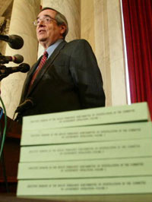
Alex Wong/Getty Images
On May 5, 2003, associate U.S. Senate historian Dr. Donald Richie speaks at a media conference on the release of McCarthy era records.
Born in Wisconsin in 1908, Joseph Raymond McCarthy attended Marquette University and became an attorney in 1935, smack in the middle of the Great Depression. He became the youngest circuit court judge in Wisconsin history when he defeated an incumbent in 1939. During World War II, he joined the Marines, where he was promoted to captain. After two years, though, he left because of a broken bone in his foot that was suffered during a hazing ritual. In 1944 he ran for U.S. Senate, parlaying his military service into the patriotic persona of "Tail Gunner Joe." He didn't win that time, but did take the ticket in 1946 when he became Wisconsin's junior senator.
McCarthy burst onto the national scene several years later. In 1950, during a highly controversial speech at a Lincoln's Birthday luncheon, he waved around a list of 205 names of supposed active communists holding jobs in the State Department.
McCarthy was a relative unknown, but once he lit the fire under America's fear of communism, there seemed to be no stopping it. There had already been some cases of communist spies selling and giving secrets to the Soviet Union about the American government and nuclear program. McCarthy claimed that liberal officials knew of other threats to national security but were taking a soft approach toward identifying them.
Two things happened almost immediately after McCarthy's speech:
- Americans became frantic to identify and remove communists from positions of power. Many believe this hysteria to have been generated not completely by McCarthy, but rather by the events that preceded his speech. Communists, led by Mao Zedong, had gained control of China two months earlier. The Soviet Union had exploded an atomic bomb in 1949. And leaders of the Communist Party of the United States had recently been convicted of conspiring to violently overthrow the U.S. government. McCarthy's speech was the icing on the cake.
- Politicians of all parties began to attack McCarthy's claims.
McCarthy then embarked on what is often described as a "witch hunt" to root out and prosecute communists and sympathizers -- using controversial techniques and often making accusations with scant evidence.
Julius and Ethel Rosenberg
Before McCarthy's crusade, numerous people were convicted for espionage and other activities related to communism. The most notorious were Julius and Ethel Rosenberg, the only U.S. citizens executed for espionage during the Cold War. In 1950, the Rosenbergs, known communists, were arrested on suspicion of espionage and providing nuclear secrets to the Soviets. They steadfastly maintained their innocence but invoked their Fifth Amendment right to avoid incriminating themselves. The couple was convicted in 1951 and executed on June 19, 1953. It is believed that the information they provided to the Soviet Union led directly to its successful development of the atomic bomb [source: Atomic Archive].

McCarthy's Tactics
McCarthy identified suspected communists through a variety of channels. Some were members of organizations with reported communist sympathies. Some were associates of known communists, and homosexuality was also an apparent cause of suspicion. However they were identified, McCarthy took aim at his targets with great tenacity.
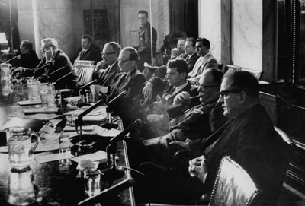
Hank Walker/Time Life Pictures/Getty Images
Sen. Joseph R. McCarthy at Senate labor hearings
Once McCarthy's claims gained national attention, he became chairman of the Senate Committee on Government Operations. This increased level of power afforded him the opportunity to investigate the people he suspected of being communists or sympathizers. Hundreds of witnesses were brought before the Senate committee, in both public and private hearings. Transcripts of the Senate hearings, which became available in 2003, confirm what the American public eventually realized about McCarthy's interview tactics. He used severe intimidation, and often the threat of prison, when trying to get information -- and he often had little or no solid evidence on which to base his claims. The names of many witnesses and suspects were released publicly, resulting in defamation of character and guilt by association. Careers and reputations were irreversibly damaged. And when all was said and done, there were no convictions for subversion.
"McCarthyism"
The term "McCarthyism" was coined in a Washington Post cartoon by Herbert Block that ran on March 29, 1950. It showed Republicans forcing an elephant, their party symbol, to stand on a precarious pile of tar buckets. The highest bucket was tagged "McCarthyism," and the caption quoted the elephant saying, "You mean I'm supposed to stand on that?"
Liberals and conservatives alike agreed that McCarthy's actions were reckless and that his methods were out of line. In fact, his actions directly resulted in a 1957 Supreme Court ruling that secures the constitutional rights of witnesses during a congressional investigation. In other words, even though congressional investigations don't take place in an actual court, witnesses cannot be subjected to less-than-ethical interrogation methods.
One of the most enduring legacies of McCarthyism was its effect on Hollywood. Next, we'll learn about McCarthy's targeting of the film industry.

Attacking Hollywood
Many of the people whom McCarthy suspected of having communist ties were Hollywood figures, including major actors, screenwriters, directors and producers. Here are a few common terms associated with McCarthy's attack on Hollywood:
- Entertainment industry blacklist: This is the list of members of the entertainment industry who had suspected or real ties to communism. Those on the blacklist were refused employment based on their political ties. A full list of the artists blacklisted is available at Bookrags.com.
- The Hollywood Ten: The first 10 members of the Hollywood film industry questioned by McCarthy decided not to cooperate with the investigation, choosing instead to claim their First Amendment right to free speech. Unfortunately for them, they were not successful. Eight were sentenced to a year in prison for contempt of Congress. The other two received six-month sentences. A full list of the Hollywood Ten and their credentials is available at the Library at the University of California, Berkeley.
- The Waldorf Statement: This was issued by Hollywood executives announcing the firing of the Hollywood Ten.
- Fifth Amendment Communists: After the Hollywood Ten debacle, future suspects often claimed the Fifth Amendment, which protects against self-incrimination. Many of their bosses considered that as good as a guilty plea, and most were fired.
- The $64 Question: "Are you now or have you ever been a member of the Communist Party of the United States?"
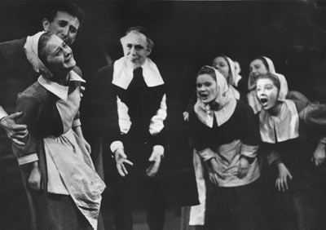
Thurston Hopkins/Picture Post/Getty Images
Arthur Miller's play "The Crucible" was a not-so-subtle criticism of McCarthyism.
McCarthyism's effect on Hollywood and the world have been documented on film numerous times, most recently in the movie "Good Night, and Good Luck." The blacklisted artists have written many memoirs, and there are plenty of nonfiction works describing the era in great detail. One of the most famous works is Arthur Miller's 1953 play "The Crucible," written during the height of McCarthyism. Miller used the Salem witch trials as a metaphor for McCarthy's communist "witch hunt," earning the ire of McCarthy. He was questioned and found guilty of having communist beliefs, but the conviction was overturned in 1957.
As it turns out, many of the people McCarthy targeted actually did have communist ties, but much of the proof wasn't revealed until years later.

Communism in the United States
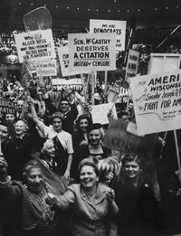
Hank Walker/Time Life Pictures/
Getty Images
A rally of McCarthy supporters
The irony of the whole McCarthy scandal is that, despite his highhandedness, lack of evidence and general recklessness, there definitely was a communist presence in the United States at the time, as illustrated by the Rosenbergs and others. In fact, a number of the people McCarthy interrogated were later identified as communists and even Soviet agents. The evidence he had so desperately sought became available in 1995 with the release of the Venona intercepts. These secret Soviet intelligence messages had been decoded in the 1940s but didn't become public knowledge until 1995. According to journalist Charles Peters, the Venona intercepts identified multiple communists, including:
- Two atomic spies
- A captain in the U.S. Navy
- One person who had enough clout to hold a private meeting with Roosevelt and Churchill
- One who held a top office in today's equivalent of the Central Intelligence Agency [source: Peters]
10 senior-level government officials suspected by McCarthy were also later shown to have Communist Party ties. The Venona intercepts, coupled with Kremlin archive data, proved that "rather than being blameless martyrs, all were indeed communists, Soviet agents or assets of the KGB, just as McCarthy had suggested" [source: Evans].
McCarthy also questioned Michael and Ann Sidorovich, couriers for convicted communists Julius and Ethel Rosenberg. The Venona intercepts show that both were full-time agents for the KGB.
Friends and Enemies
McCarthy's supporters included:
- Much of the American public. According to Conservapedia, McCarthy's popularity peaked in early 1954, when a Gallup Poll reported that 50 percent of the respondents had a generally favorable opinion of him. He also took fourth place on a list of most admired men.
- The American Legion
- Minute Women of the U.S.A.
- American Public Relations Forum
- Christian organizations
Detractors included such heavy hitters as:
- President Harry Truman, who reportedly ignored warnings by the FBI that Harry Dexter White had communist ties. Truman promoted him to a top-level position at the International Monetary Fund. White was later revealed to be a Soviet agent.
- Lyndon B. Johnson
- Politicians of all parties
- Edward R. Murrow, host of "See It Now." Its March 9, 1954, episode portrayed McCarthy in an extremely unflattering light -- some consider it to be the beginning of the end of McCarthy.
- The Communist Party (surprise)
But it wasn't long before McCarthy's detractors started to outweigh his supporters, and the stage was set for his eventual downfall.

The Fall of McCarthy
Television, the medium that makes or breaks so many, was ultimately McCarthy's downfall. McCarthy had been viciously interrogating suspects in public and private hearings for some time, but the American people witnessed his brutal methods firsthand when the Army-McCarthy hearings were broadcast on live TV in 1954 (the doing of President Eisenhower, who wanted the public to see McCarthy's misdeeds). The hearings began generically enough, with McCarthy making accusations against Army officers for not answering questions about their political beliefs. Lt. Col. Chester T. Brown, for one, outright refused to answer McCarthy's questions. In response, McCarthy said, "Any man in the uniform of his country who refused to give information to a committee of the Senate which represents the American people, that man is not fit to wear the uniform of his country" [source: CNN]. McCarthy then went one step further when he interviewed Brigadier General Ralph Zwicker, a decorated veteran and hero in Normandy, calling him "a disgrace to the uniform he wore" [source: Kiehr].
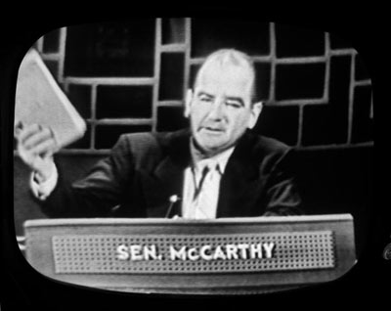
CBS Photo Archive/Getty Images
McCarthy on the premiere broadcast of the TV show "Face the Nation," Nov. 7, 1954
McCarthy had finally gone too far. Joseph Welsh, the attorney for the U.S. Army, responded famously by saying, "I think I never really gauged your cruelty or your recklessness. Have you no sense of decency, sir, at long last?" [source: Kiehr] The public quickly shifted its opinion of the man who had insulted members of the Armed Forces. President Eisenhower and the rest of the Senate agreed with Welsh. In 1954, the Senate censured McCarthy on 46 charges for abuse of legislative powers. He was eventually censured on only two of the charges because the Senate didn't want to project the image of being "soft" on communism. Instead, the censure resolution stated that he had abused his power as a senator. He remained in office but was left with virtually no power or clout.
McCarthy died on May 2, 1957, of acute hepatitis, which resulted from alcohol abuse. He was 48 years old.
The 1995 release of the Venona intercepts caused some to view McCarthy's legacy differently. Maybe he had, in fact, been a crusader against communism in a country that wasn't taking a tough enough approach. But most remember him as violating the civil liberties of too many innocent people -- and even some guilty people. He is still generally considered a reckless bully who used whatever means necessary to obtain the information he wanted. His actions certainly cost some of the accused their careers and livelihoods.
If nothing else, historians hope that others will learn from McCarthy's mistakes. When the Senate hearing transcripts were released in 1995, Senator Susan Collins said, "We hope that the excesses of McCarthyism will serve as a cautionary tale for future generations" [source: Frommer]. Only time will tell if that will be the case.
For more information about McCarthyism, take a look at the links on the next page.
Is McCarthyism Alive and Well?
McCarthyism left an indelible imprint on the American psyche. Many political buffs are constantly on the lookout for cases of it. In fact, www.progressive.org has a whole section titled "McCarthyism Watch," in which author Matthew Rothschild details suspected cases. Usually, they include violation of civil liberties and suspected political highhandedness. Some headlines include:
- Anti-Bush Protesters Prosecuted for "Unauthorized Display of Sign"

- VA Police Delete Photographs Taken by Muslim-American Journalism Student
- Muslim-American Detained at Border for Fifth Time
- Iraq Vet Faces Penalty for Protesting War
Whether or not any of these, and other stories, constitute true McCarthyism is a matter of opinion. However, with such a storied history of abuse of authorty by high-level officials, many believe it can't hurt to keep tabs on those in power.

